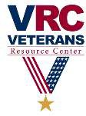
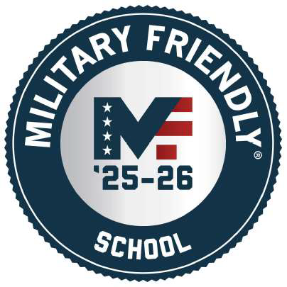
2026-2027 CCTC VA STUDENT CHECKLIST

Completed CCTC Admissions Application and registered for classes?
YES (Continue to Step 2)
Developmental 03x MAT, RWR, etc. must be taken in A, Z, V format to be certified for VA educational benefits. Online or hybrid (L or H) format developmental classes cannot be certified.
NO (No action can be taken until admitted & enrolled in classes)

Applied for VA Educational Benefits?
YES (Continue to Step 3)
NO (No action can be taken until your application is complete)
Your application must be submitted here: How To Apply For The GI Bill And Related Benefits | Veterans Affairs . Once approved, the VA will mail you a Certificate of Eligibility (COE) letter. A copy must be submitted to the CCTC VA Fin Aid. For Chap 31: VA counselor will submit via the Tungsten system to CCTC VA Fin Aid.

Did you use VA Educational Benefits at another College/University/Training Program?
NO (Continue to Step 4)
YES (Submit prior transcripts to registrar) and (submit VA transfer form)
Veteran: Complete VA 22-1995, Change of Program or Place of Training form
Child/Spouse of Veteran: Complete VA 22-5495, Change of Program or Place of Training form

- Submitted copy of Certificate of Eligibility (COE), or printed education eligibility information from eBenefits (va.gov), or NOBE from Reserve unit, (for Chap 30, 33, 35, or 1606 scanned & emailed or brought in for a copy to be made) or VR&E counselor submitted form via Tungsten to CCTC VA Rep (for Chap 31)?
YES (Continue to Step 5) Chap 35 must provide full SSN of Veteran Sponsor
NO (No action can be taken without COE or proof of educational benefits)

Student is the child of disabled/injured/wounded SC Veteran (Chap 35)?
NO (Continue to Step 6)
YES (Student may be eligible for tuition waiver) Go to the form by clicking here.
If approved submit copy of SC Dept of VA waiver letter to the CCTC VA Rep and Bu for processing.

Submit the CCTC Veteran Certification Request form here. Required each semester.
https://cctech.my.salesforce-sites.com/Inquiry/TargetX_Base__InquiryForm#?formId=a0APF000004n3Lp2AI&formType=general

NO (No action can be taken until request is submitted)
YES (Welcome to CCTC & the use of your VA Educational Benefits)

  - Consider completing the FAFSA (Free Application for Federal Student Aid) for other federal financial aid. www.studentaid.gov

  - Review the Standards of Academic Progress by clicking here.
The CCTC VA Representative will use the above submitted information to process your certification request and submit this information to the VA for final action. Please notify the CCTC VA Representative of any changes to your schedule/enrollment or if you have questions. Email vrc@cctech.edu
Change Effective 5/20/2026

